ls

* To list directory contents of files and directories
* Syntax: ls [option] [file/dir]

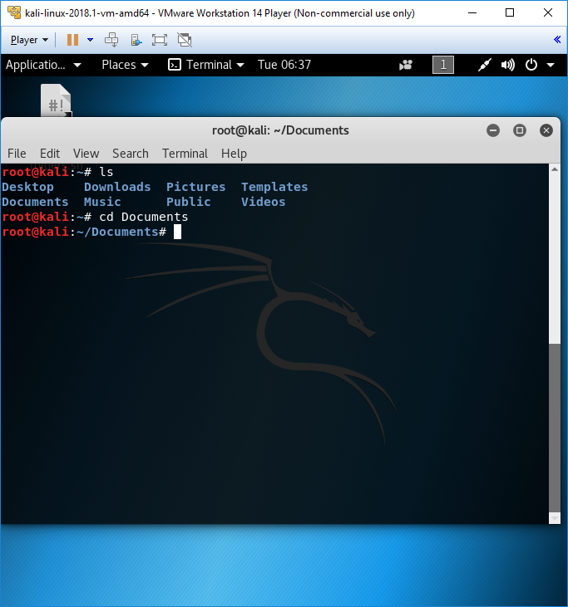

cd

* To change the current working directory
* Syntax: cd [option] [directory]
  + cd .. : to go back one directory
  + cd Documents : to change into Documents directory



mv

* To moves, renames files and directories on your filesystem
* Syntax: mv [option] [-T] source destination (To rename mv [option] source [source2 …] destination (To move source file to a directory named destination)

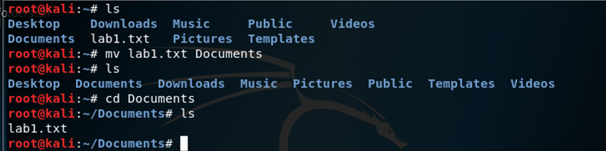

cat

* To create single or multiple files, view contain file, concatenate files and redirect output in terminal or files
* Syntax: cat [option] [file] …
  + cat > ‘file name’ (Create a file)
  + cat ‘file name’ (To display a file)
  + cat >> ‘file name’ (To add data to an existing file)

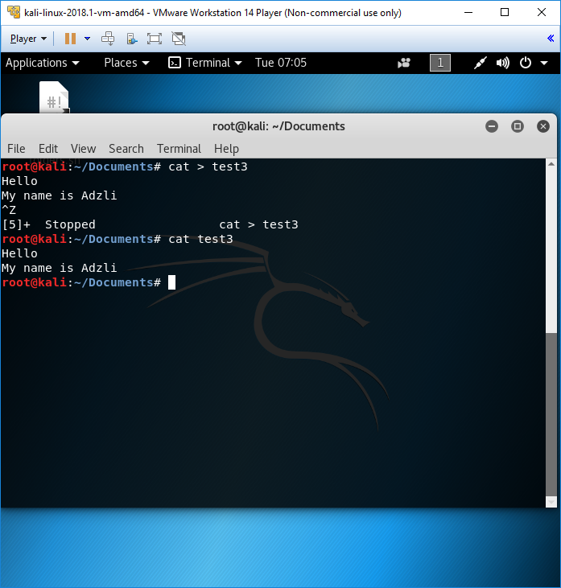

rm

* To delete file. When used recursively, it may be used to delete directories
* Syntax: rm [file]

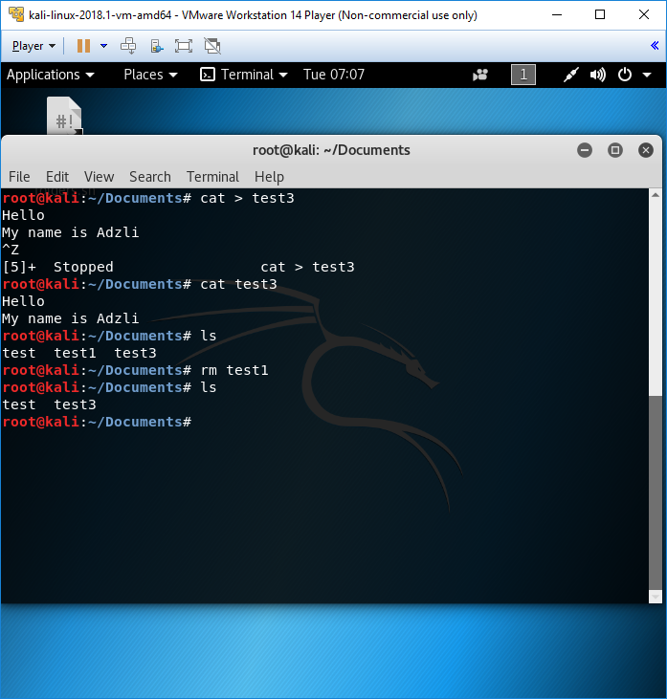

mkdir/rmdir

* mkdir: To create new directories
  + Syntax: mkdir [option] ‘directory name’

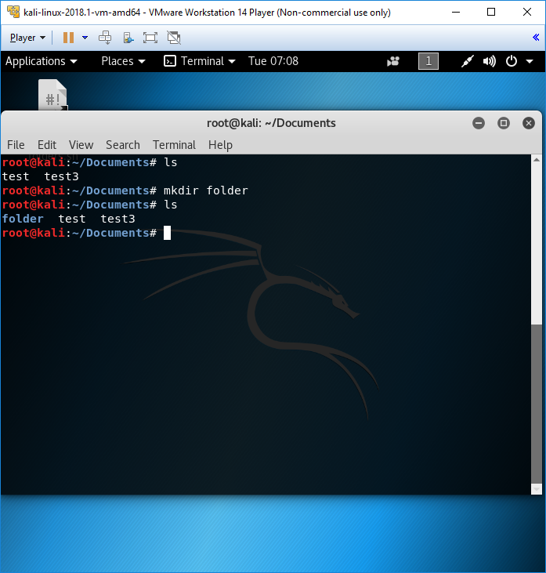

* rmdir: To remove empty directories from your filesystem
  + Syntax: rmdir [option] ‘directory name’

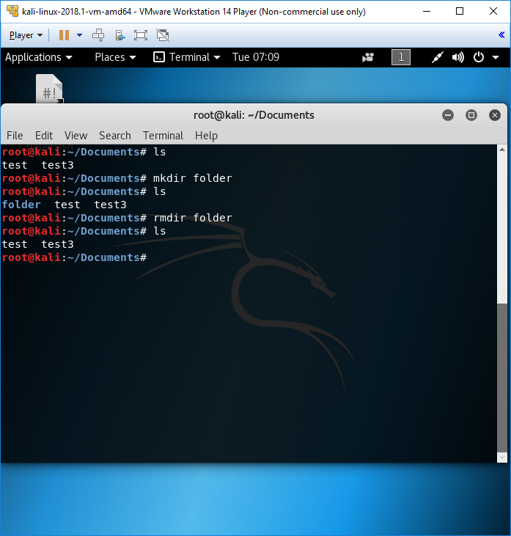

touch

* Easiest way to create new, empty files. Also used to change the timestamps on existing files and directories
* Syntax: touch [option] ‘file name’

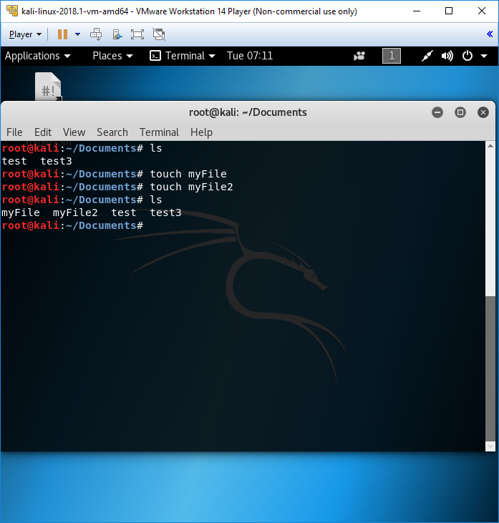

pwd

* To print the name of the working directory
* Syntax: pwd [option]

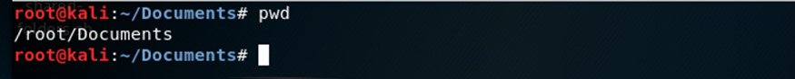

top

* To display processor activity of your Linux box and also display tasks managed by kernel in real-time. It’ll show processor and memory are being used and other information like running processes
* Syntax: top

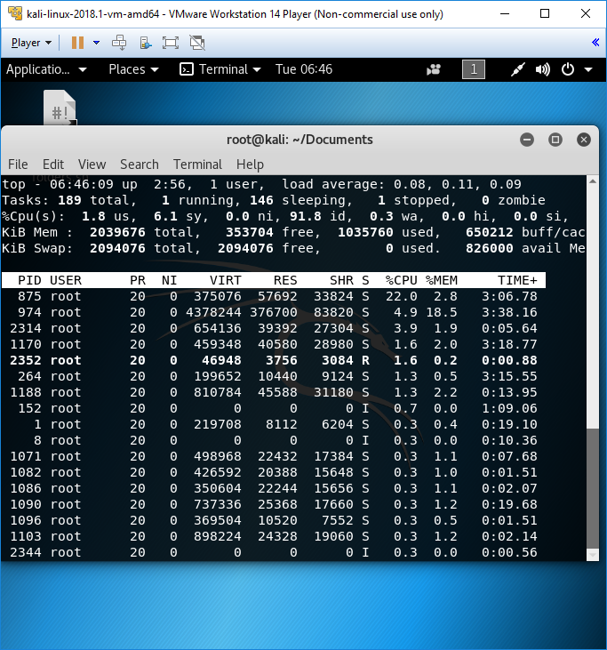

ps

* To provide information about the currently running processes, including their process identification numbers (PIDs)
* Syntax: ps [options]

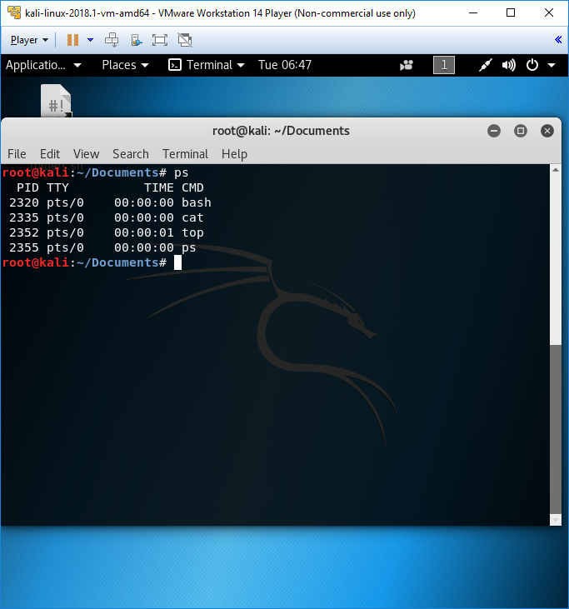

kill

* To terminate processes without having to log out or reboot the computer. It is particularly important to the stability of such system.
* Syntax: kill [signal or options] PID(s)

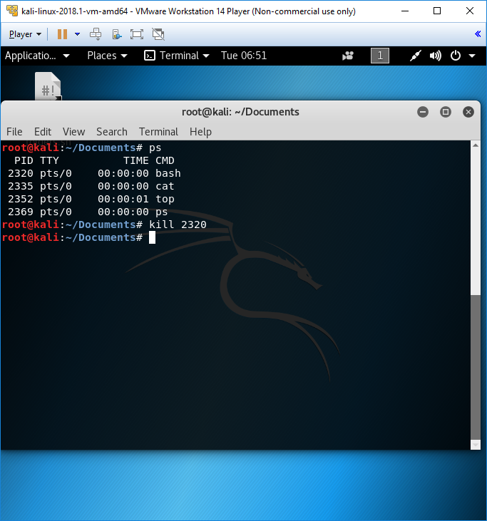

wc

* To find out number of newline count, word count, byte and characters count in files specified by the file argument
* Syntax: wc [options] filename
  + wc -l : Prints the number of lines in a file
  + wc -w: Prints the number of words in a file
  + wc -c: Display the count of bytes in a file
  + wc -m: Prints the count of characters from a file
  + wc -L: Prints only the length of the longest line in a file

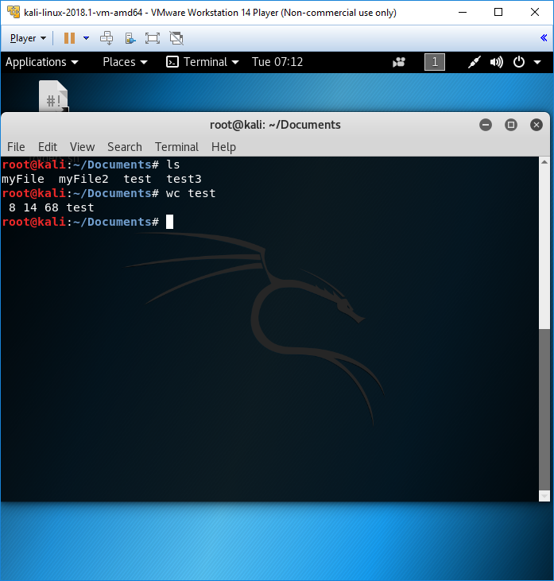

grep

* To processes text line by line and prints any lines which match a specified pattern
* Syntax: grep [options] PATTERN [file..]

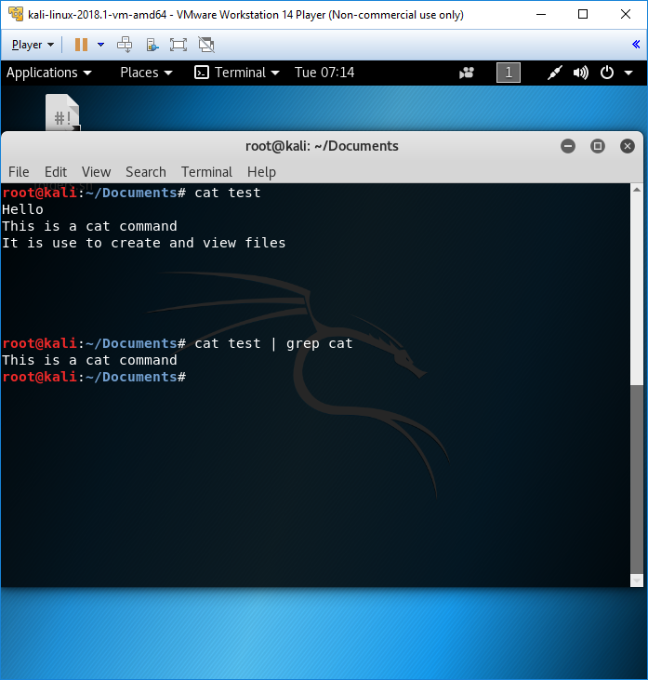

more/less

* more: To display text, one screen at a time.
  + Syntax: more [options] filename
    - Options:
      * -num: This option specifies an integer which is the screen size (in lines).
      * -d: more will prompt the user with the message "[Press space to continue, 'q' to quit.]" and will display "[Press 'h' for instructions.]" instead of ringing the bell when an illegal key is pressed.
      * -l: more usually treats ^L (form feed) as a special character, and will pause after any line that contains a form feed. The -l option will prevent this behavior.
      * -f: Causes more to count logical, rather than screen lines (i.e., long lines are not folded).
      * -p: Do not scroll. Instead, clear the whole screen and then display the text.
      * -c: Do not scroll. Instead, paint each screen from the top, clearing the remainder of each line as it is displayed.
      * -s: Squeeze multiple blank lines into one.
      * -u: Backspaces and carriage returns to be treated as printable characters;
      * +/: This option specifies a string that will be searched for before each file is displayed. (Ex.: more +/Preamble gpl.txt)
      * +num: Start at line number num.

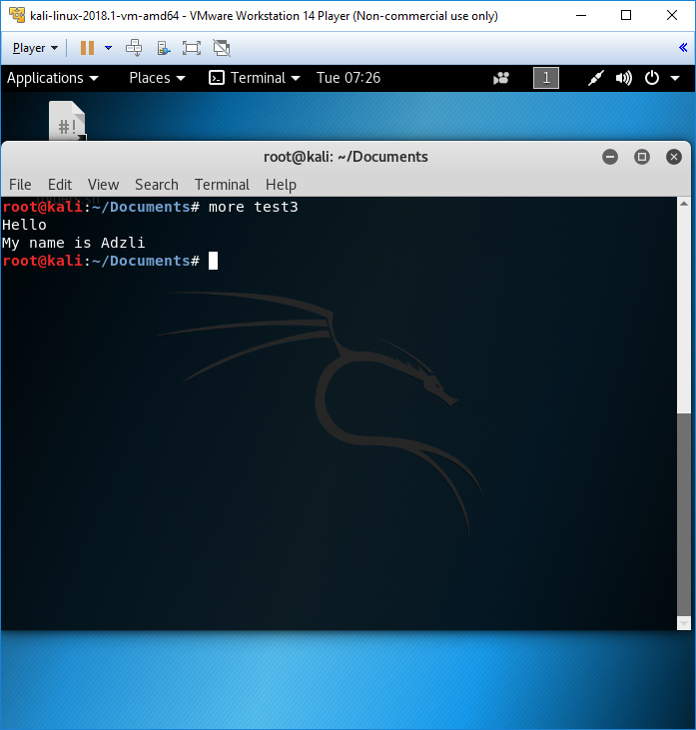

* less: Similar to more but allows backward movement in the file as well as forward movement. Also, less does not have to read the entire input file before starting, so with large input files it starts up faster than text editors.
  + Syntax: less [option] filename
    - Options:
      * -g: Highlights just the current match of any searched string.
      * -I: Case-insensitive searches.
      * -M: Shows more detailed prompt, including file position.
      * -N: Shows line numbers (useful for source code viewing).
      * -S: Disables line wrap ("chop long lines"). Long lines can be seen by side scrolling.
      * -X: Leave file contents on screen when less exits.
      * -?: Shows help.
      * +F: Follow mode for log.

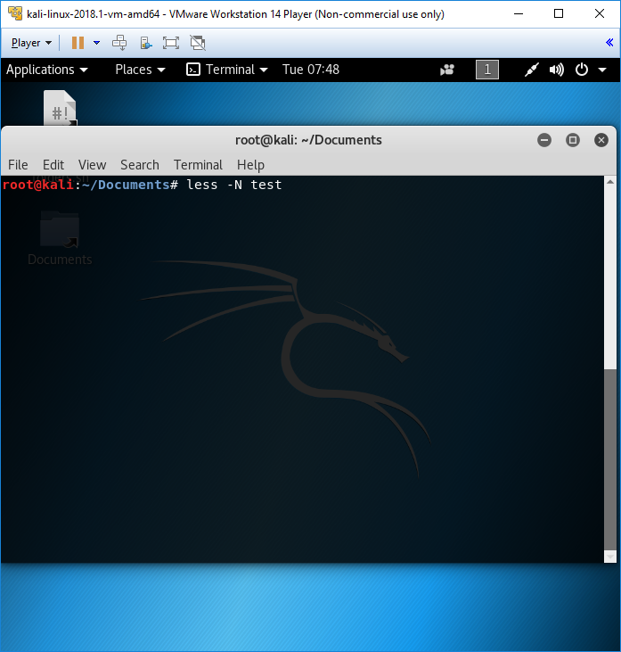

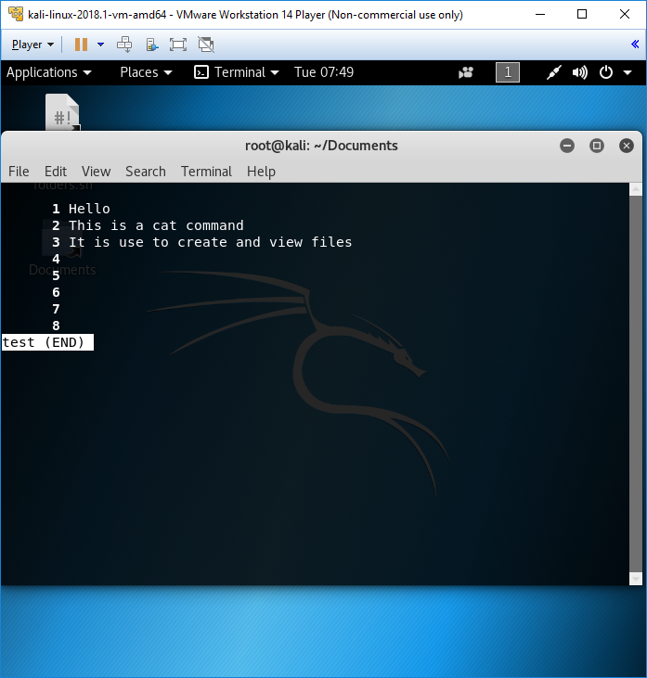

ping

* To send ICMP ECHO_REQUEST packets to network host. It is frequently used to test, at the most basic level, whether another system is reachable over a network, and if so, how much time it takes for that data to be exchanged.
* Syntax: ping [option] [destination]

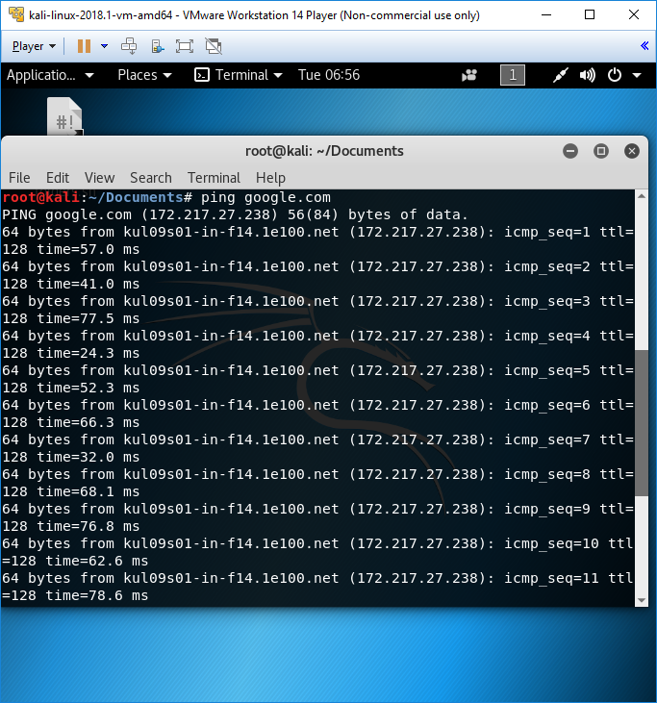

uname

* To print information about the current system such as the name and version
* Syntax: uname [option]

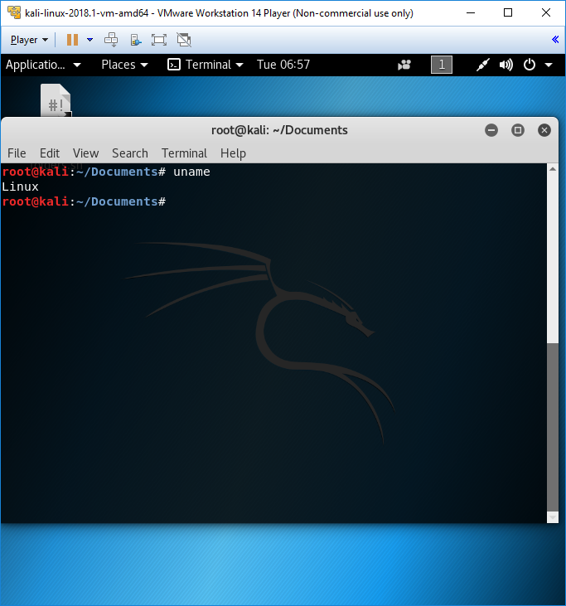

uptime

* To tells you how long the system has been running
* Syntax: uptime

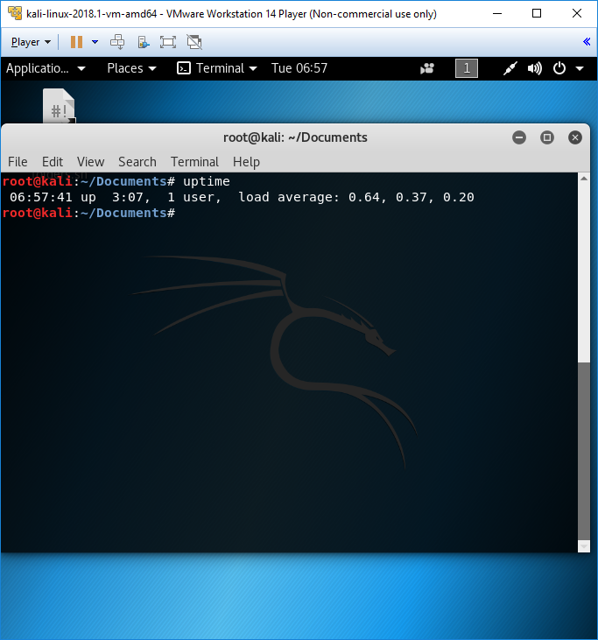

netstat

* To print network connections, routing tables, interface statistics, masquerade connections, and multicast membership.
* Syntax: netstat

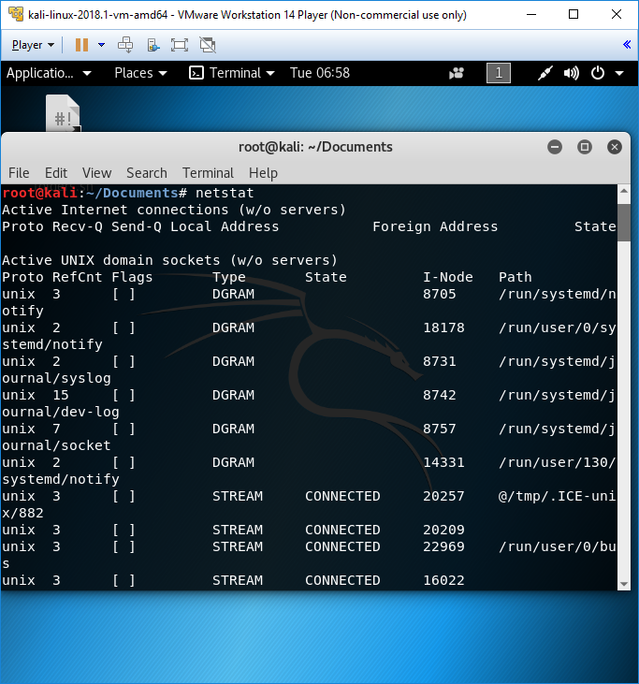

chmod

* To change the permissions of files or directories
* Syntax: chmod [options] [permission] [filename]

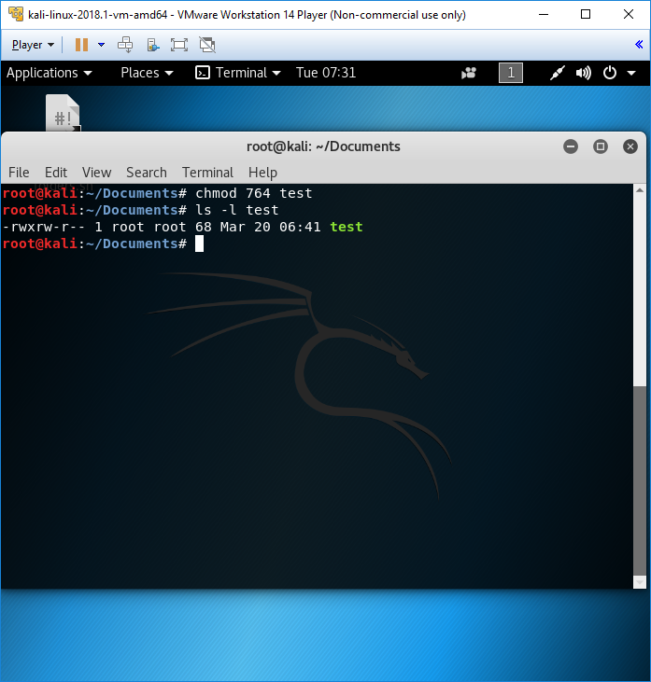

chown

* To change ownership of files and directories in a linux filesystem
* Syntax: chown [option] [filename]

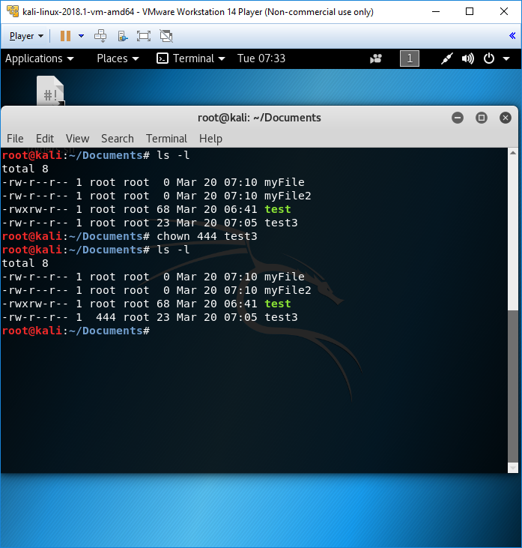

file

* To determine a file’s type
* Syntax: file [filename]

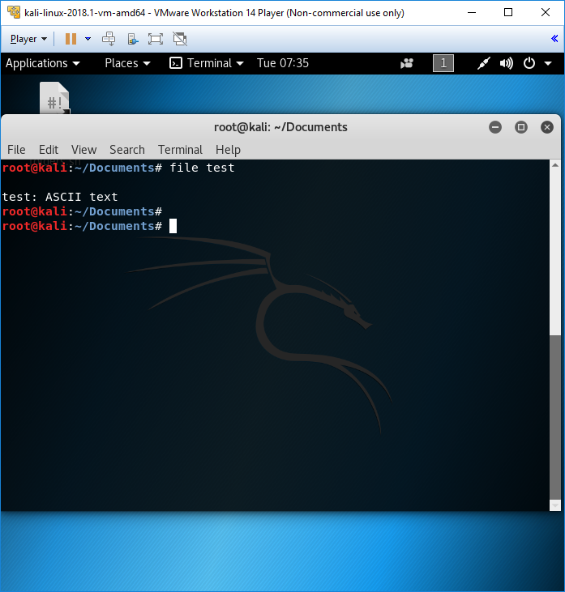

ln

* To creates a link to a file target with the name LINKNAME. If LINKNAME is omitted, a link to target is created in the current directory using the name of target as the LINKNAME
* Syntax: ln [option] [filename]
  + Option:
    - -f Force existing destination pathnames to be removed to allow the link.
    - -L For each source_file operand that names a file that is a symbolic link, create a hard link to the file referenced by the symbolic link.
    - -P For each source_file operand that names a file that is a symbolic link, create a (hard) link to the symbolic link itself.
    - -s Create symbolic links instead of hard links. If the -s option is specified, the -L and -P options are silently ignored

